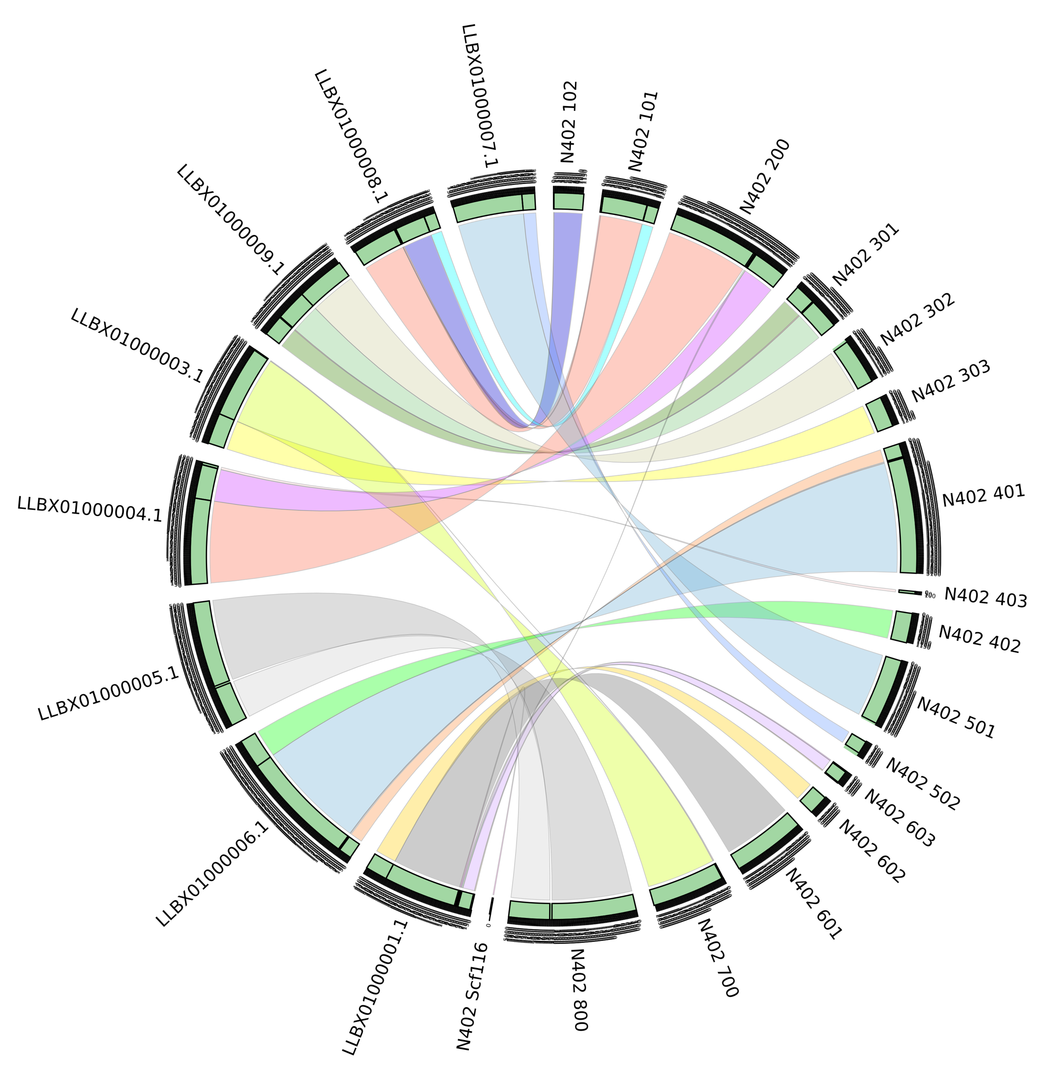

Supplementary figure 2. Sequence identity and synteny between the proposed genome assemblies of Aspergillus niger strains N402 and H915-1. The genome comparison is plotted in circos format (Krzywinski et al., 2009).

